Announcement of Nongkham Police Station
Subject: Intention to not accept any kind of gifts from performing duties
(No Gift Policy)
-------------------------------------------------
Nongkham Police Station is determined to develop transparent operations, adheres to common interests more than personal interests and without conflict of interest in accordance with the National Reform Plans on Prevention and Suppression of Corruption andMalfeasance (Revised Edition), which aims for agencies to operate with transparency,
without confiict of interest. All government officials shall not accept any kind of gifts from
performing duties. (No Gift Policy)
Therefore, we would like to announce the intention of the Superintendent Nongkham Police Station and all police officers to not accept any kind of gifts while
performing duties (No Gift Policy). We will together establish organizational culture and integrityvalue at work, not accepting the patronage system, avoiding actions that may affect discretionor decision-making during performing duties that would lead to discrimination. Also, wecooperatively prevent the unfair performance of duties and a confiict of interest along withbuilding public trust by performing our duties with good governance.

It is hereby announced and to strictly adhered to all.

This announcement is hereby issued on March 8th, 2025.
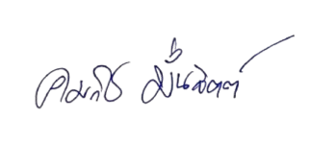

Police Colonel
( Komhrit Munjit )
Superintendent Nongkham Police Station

